

United States v. Allen
United States District Court for the District of Columbia
November 21, 2023, Decided
Criminal Action No. 23-73-17 (CKK)

Reporter
2023 U.S. Dist. LEXIS 208960 *; 2023 WL 8086551
UNITED STATES OF AMERICA v. MELVIN EDWARD ALLEN, Defendant.
Subsequent History: Appeal filed, 12/11/2023
Prior History: United States v. Nava, 2023 U.S. Dist. LEXIS 73919, 2023 WL 3158987 (D.D.C., Apr. 28, 2023)
Core Terms

detention, magistrate judge, pills, pending trial, firearms, messages, indictment, fentanyl, de novo review, conditions, flight, detention order, counterfeit, appearance, detained, proffers, drug trafficking, circumstances, conspiracy, distribute, recovered, drugs, media, weight of the evidence, convincing evidence, communications, memorandum, pretrial, alleges, factors
Counsel: [*1] For MELVIN EDWARD ALLEN, Defendant: Elita C. Amato, LEAD ATTORNEY, ATTORNEY AT LAW, Arlington, VA USA.
For Matthew William Kinskey, Plaintiff: LEAD ATTORNEY, USAO, Washington, DC USA; Solomon Eppel, LEAD ATTORNEY, DEPARTMENT OF JUSTICE, Washington, DC USA; Andy Wang, UNITED STATES ATTORNEY'S OFFICE FOR THE DISTRICT OF COL, Washington, DC USA; David T. Henek, U.S. ATTORNEY'S OFFICE FOR THE DISTRICT OF COLUMBIA, Washington, DC USA.
Judges: COLLEEN KOLLAR-KOTELLY, United States District Judge.
Opinion by: COLLEEN KOLLAR-KOTELLY
Opinion

MEMORANDUM OPINION
Defendant Melvin Edward Allen is charged by indictment with conspiring to distribute, with others, thousands of counterfeit pills of fentanyl. On November 17, 2023, Magistrate Judge Robin M. Meriweather of this jurisdiction ordered Defendant to be released with conditions pending trial. See ECF No. 177. Magistrate Judge Meriweather stayed the detention order until November 24, 2023. Id.
Before the Court is the Government's [172] Emergency Motion for De Novo Review of Magistrate's Release Order and Request to Stay Defendant's Release Pending De Novo Review. The Government requests that the Court vacate the detention order and order Defendant detained pending trial, or, [*2] in the alternative, stay the detention order pending the conclusion of the de novo review process. The Government moves on an emergency basis on account of the limited stay issued in this matter. Upon consideration of the pleadings,¹ the relevant legal authority, and the record before the Court, the Court shall GRANT the Government's Motion, VACATE the prior release order, and order Defendant held without bond pending trial.
I. BACKGROUND
The factual record thus far is underdeveloped. There is no opinion or memorandum attached to the Magistrate Judge's detention order. See ECF No. 177. The Magistrate Judge's Minute Order reveals that Magistrate Judge Meriweather expressed concern "regarding the weakness of the evidence," as law enforcement did not recover any "drugs or drug trafficking paraphernalia," there were "no observed sales of narcotics, and no controlled purchases from undercover [*3] agents." See Nov. 21, 2023 Minute Order. In addition, Magistrate Judge Meriweather noted Defendant's lack of a criminal history, before ultimately concluding "conditions of release could be fashioned to reasonably assure the safety of the community and [Defendant Allen's] appearance as required." Id. In an exercise of its discretion, the Court will rule definitively upon the record presently before it, sparse as it is. See United States v. Sheffield, 799 F. Supp. 2d 18, 20 (D.D.C. 2011) (BAH) ("The Court is free to use in its analysis any evidence or reasons relied on by the magistrate judge, but it may also hear additional evidence and rely on its own reasons.") (cleaned up). As discussed further below, to the extent defense counsel discovers additional evidence or develops further argument after consultation with her client, the Court welcomes motions for reconsideration, which the Court would review "as justice requires." See United States v. Caldwell, Crim. A. No. 21-181 (CKK), 2022 U.S. Dist. LEXIS 10043, 2022 WL 168343, at *5 (D.D.C. Jan. 19, 2022). The Court makes this determination based on the Government's exceptionally strong showing here of danger to the community and risk of flight.
A. Procedural Background
On March 9, 2023, the Government filed an indictment against Defendants Hector David Valdez, Craig Eastman, and Charles Jeffrey Taylor. ECF No. 1 (sealed). [*4] Additional defendants were indicted on April 26 and May 18, 2023. See ECF No. 25 (sealed); ECF No. 48 (sealed). On November 6, 2023, a grand jury returned a third superseding indictment, adding, among others, Defendant Allen. ECF No. 134 (sealed). Magistrate Judge Meriweather then issued an arrest warrant for Defendant, which appears to have been executed on November 9, 2023. ECF No.140. On November 17, 2023, a grand jury returned a fourth superseding indictment in this matter. ECF No. 168 (sealed). That same day, Defendant appeared before Magistrate Judge Meriweather for a detention hearing. There, Magistrate Judge Meriweather ordered the release of Defendant, but stayed the detention order until November 24, 2023, to afford the Government an opportunity to appeal to this Court. See Nov. 21, 2023 Minute Order.
The Government did so, filing its emergency Motion the morning of November 21, 2023. ECF No. 172. Counsel for Defendant filed her response at approximately 1:30 p.m. this afternoon, November 21, 2023. ECF No. 179.
B. Factual Allegations
In its motions, the Government details the allegations against Defendant, posts and messages from his social media account, as well as text messages [*5] exchanged between Defendant and co-Defendant Valdez, and the ammunition seized through search of Defendant's residence. Broadly, the Government alleges that Defendant served as "redistributor of [fentanyl-laced counterfeit oxycodone pills], as well as an intermediary through whom Valdez met additional D.C.-based fentanyl traffickers." Mot. at 2-3. A search of Defendant's residence in Maryland uncovered ammunition (but no firearm). Id. at 8. A subsequent search of Defendant's preferred "store" (i.e., a marijuana dispensary) uncovered additional firearm magazines and rounds of various calibers. Id. at 9.
The Government recounts purported social media messages and text messages between Defendant and Valdez. Id. at 5. According to the Government, the below messages were recovered from Valdez's phone, demonstrating Defendant's illicit dealing in vast quantities of lethal drugs. Id. For instance, on November 4, 2022, Defendant messaged Valdez, stating "I got someone else coming Sunday morning," referring to a client. Id. He then messaged Valdez again, "I need them for 50. So I can tell them 60." Id. Valdez responded, "I don't even get them for 50 g tbh." Id. The Government proffers this communication [*6] reveals that Defendant wanted to tell buyers that the pills were $0.60, so he asked for the pills for $0.50 to profit. Id.
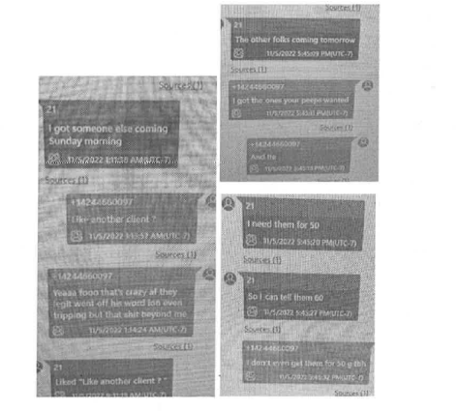
Id. Notably, Defendant's communications with Valdez carries strong implications. The Government proffers that Valdez "served as the primary distributor of fentanyl-laced counterfeit oxycodone pills to D.C.-based redistributors," including Defendant. Id. at 2. In addition, messages from Defendant's social media account (Instagram) reflect his distribution of illicit drugs. See id. at 6-7. For instance, on or around July 24, 2021, Defendant received a message asking "you got blues out there?" Defendant responded, "yea." Id. at 7.
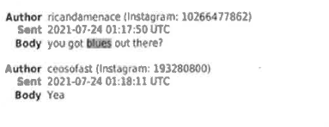
Id. The Government proffers that the "blues" in question refer to the counterfeit fentanyl pills. Id. at 6. Moreover, the Government proffers that Defendant "has conducted nearly $1.2 million in transactions . . . since he was identified as a target of the drug trafficking network in this investigation." Id. at 4. The Government appends photographs depicting Defendant displaying copious amounts of cash.
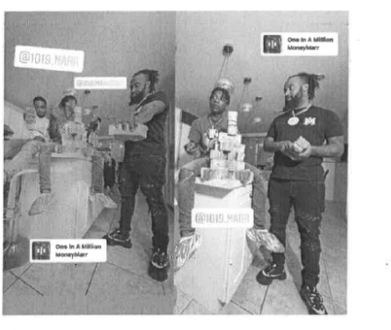
Id. Finally, Government claims that Defendant possesses firearms, appending additional images recovered from his social media account to corroborate [*7] this claim. Id. at 7.
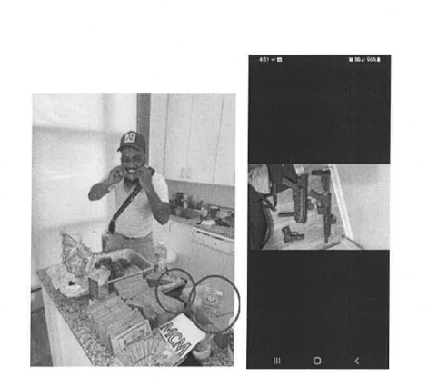
Id. at 7-8. Similarly, a search of a marijuana dispensary in Washington, D.C., which Defendant Allen called "[his] store," uncovered a "plastic bag containing three empty firearm magazines" and a "mylar bag containing 26 rounds of various calibers." Id. at 9-10.
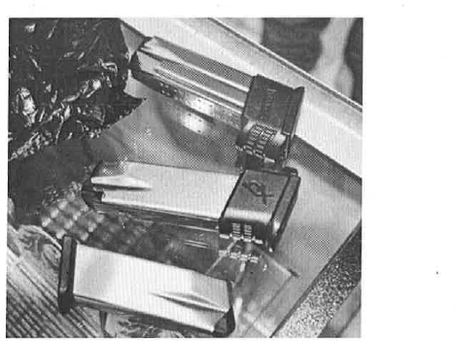
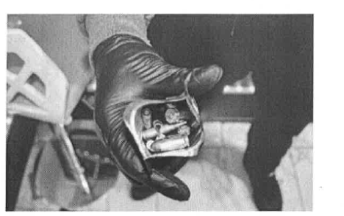
Id. at 9-10. Finally, the Government proffers that Defendant frequently travelled to Los Angeles, California to obtain the pills. Id. at 8. Specifically, the Government claims that Defendant would purchase "bulk quantities of pills" in person before "smuggling them back to the District of Columbia." Id. According to the Government, Defendant flew to "LAX at least 65 times over the life of the conspiracy," which supports his alleged role in the conspiracy: "an in-person broker who coordinated with other D.C.-based clients of Valdez," including other co-defendants, to obtain large quantities of the illicit drugs. Id.
II. LEGAL STANDARD
The Government may file "a motion for revocation of the order" with "the court having original jurisdiction over the offense." 18 U.S.C. § 3145(a). The Court applies de novo review to the question and is "free to use in its analysis any evidence or reasons relied on by the magistrate judge, but [*8] it may also hear additional evidence and rely on its own reasons." Sheffield, 799 F. Supp. 2d at 20 (quoting United States v. Hanson, 613 F. Supp. 2d 85, 88 (D.D.C. 2009)). "The motion shall be determined promptly." 18 U.S.C. § 3145(a).
In our society, "liberty is the norm" and "detention prior to trial or without trial is the carefully limited exception." United States v. Salerno, 481 U.S. 739, 755, 107 S. Ct. 2095, 95 L. Ed. 2d 697 (1987). The Bail Reform Act permits pretrial detention in only "carefully defined circumstances." United States v. Simpkins, 826 F.2d 94, 95-96, 264 U.S. App. D.C. 22 (D.C. Cir. 1987). A detention hearing must be held only if a case involves any of an enumerated set of offenses, including an offense "for which a maximum term of imprisonment of ten years or more is prescribed in[, inter alia,] the Controlled Substances Act," 18 U.S.C. § 3142(f)(1)(C), or if the defendant poses a serious risk of flight or of trying to obstruct justice or threaten, injure, or intimidate a witness or juror, id. § 3142(f)(2)(A)—(B).
The question for the Court is whether any "condition or combination of conditions will reasonably assure the appearance of the person as required and the safety of any other person and the community." Id. § 3142(e)(1). "In common parlance, the relevant inquiry is whether the defendant is a 'flight risk' or a 'danger to the community.'" United States v. Vasquez-Benitez, 919 F.3d 546, 550, 440 U.S. App. D.C. 122 (D.C. Cir. 2019). In determining whether a defendant should be detained pending trial, the Court must consider "the available information" concerning four enumerated factors: (1) [*9] the nature and circumstances of the offense charged; (2) the weight of the evidence against the defendant; (3) the history and characteristics of the defendant; and (4) the nature and seriousness of the danger to any person or the community that would be posed by the defendant's release. 18 U.S.C. § 3142(g).
"To justify detention on the basis of dangerousness, the government must prove by 'clear and convincing evidence' that 'no condition or combination of conditions will reasonably assure the safety of any other person and the community.' United States v. Munchel, 991 F.3d 1273, 1279-80, 451 U.S. App. D.C. 294 (D.C. Cir. 2021) (quoting 18 U.S.C. § 3142(f)). That standard requires the Government to establish that the defendant "poses a concrete, prospective threat to public safety" that cannot be sufficiently mitigated by release conditions. Id. at 1280; see also Salerno, 481 U.S. at 751 (requiring the Government to "prove[ ] by clear and convincing evidence that an arrestee presents an identified and articulable threat to an individual or the community"). "Detention cannot be based on a finding that defendant is unlikely to comply with conditions of release absent the requisite finding of dangerousness or risk of flight; otherwise[,] the scope of detention would extend beyond the limits set by Congress." Munchel, 991 F.3d at 1283.
III. DISCUSSION
Despite the rather underdeveloped [*10] record, the Court concludes that the evidence presented by the Government in its briefing clearly requires Defendant's detention pending trial. That said, the Court acknowledges that counsel for Defendant has had little opportunity to develop the factual record on behalf of her client given the expedited briefing schedule. If counsel discovers new evidence or develops new legal arguments that she was not able to present in the instant briefing, the Court encourages defense counsel to move for reconsideration.
A. Legal Principles
As a threshold matter, the Court must address the proper standard to apply at this stage of proceedings.² As explained above, the Government has appealed a detention order pursuant to 18 U.S.C. § 3145. Such an appeal is subject to de novo review, in which the Court must engage in a searching, "factbound inquiry" to determine danger to the community and/or risk of flight. United States v. Sabol, 534 F. Supp. 3d 58, 69 (D.D.C. 2021) (EGS) (citing Munchel, 991 F.3d at 1283) (cleaned up).
In determining whether Defendant is a danger to the community or a flight risk, the Court considers the Section 3142(g) factors including: (1) "the nature and circumstances of the offense charged"; (2) "the weight of the evidence"; (3) "the history and characteristics" [*11] of the defendant; and (4) "the nature and seriousness of the danger to any person or the community that would be posed by the [defendant's] release." 18 U.S.C. § 3142(g).
The Court shall consider these factors based upon the present record without holding an additional hearing. See Sheffield, 799 F. Supp. 2d at 20 (permitting district court to use in its analysis the evidence relied on by the magistrate judge); see also United States v. Anderson, 384 F. Supp. 2d 32, 33-34 (D.D.C. 2005) (PLF) (taking into consideration the indictment, "the briefs and other papers submitted by the parties, the proceedings before [the magistrate judge], the [magistrate's] findings of fact and conclusions of law, and the evidence and proffers before [the court]"). Based on the current record, the Court concludes that clear and convincing evidence supports a finding that no condition or combination of conditions will "reasonably assure" the "safety of any other person and the community" or flight in advance of trial. Accordingly, the Court orders that Defendant remains detained pending trial. See 18 U.S.C. § 3142(e)(1).
B. Nature and Circumstances of the Offense Charged
Turning to the Section 3142(g) factors, the Court first considers the "nature and circumstances of the offense charged" including whether the offense involves "a controlled substance." 18 U.S.C. § 3142(g)(1). In [*12] this case, a rebuttable presumption of detention applies because Defendant has been charged by indictment with serious violations of the Controlled Substances Act. See id. § 3142(e)(3)(A); United States v. Brown, 538 F. Supp. 3d 154, 165 (D.D.C. 2021) (RCL). Even the possession with intent to distribute "9.11 grams of fentanyl and .89 grams of powdered cocaine" triggers such a presumption. Brown, 538 F. Supp. 3d at 165-66. Here, the Government has presented convincing evidence that Defendant conspired to traffic, and did in fact traffic, thousands of counterfeit pills containing fentanyl. Mot. at 5-7. And, not only did Defendant allegedly traffic the counterfeit pills, the Government also alleges that Defendant served an integral role in expanding the distribution network across the United States. Id. at 14. The Court must therefore presume that no condition or combination of conditions will reasonably assure Defendant's appearance as required or the safety of the community. To rebut this presumption, Defendant must "offer some credible evidence" that he will not endanger the community or flee if released. United States v. Cherry, 221 F. Supp. 3d 26, 32 (D.D.C. 2016) (GMH).
The nature and circumstances of the offense here definitively weigh in favor of detention. Defendant is charged with conspiring to distribute and possess with intent to distribute [*13] 400 grams or more of a substance containing fentanyl, in violation of 21 U.S.C. §§ 841(a)(1), 846. This charge carries a ten-year mandatory minimum sentence, with a maximum of life. Id. § 841(b)(1)(A)(vi). "Moreover, this is not the case of an individual seller working alone." Brown, 538 F. Supp. 3d at 167. The Government alleges not just a conspiracy among the Defendants in this action, but vast distribution across the United States, which Defendant purportedly served an integral role in accomplishing. Therefore, Defendant's "alleged participation in the conspiracy charged thus strongly suggests that, if released, he would have the means to purchase and distribute narcotics and thereby endanger [not just] the D.C. community," but also communities throughout the United States. See id.
Moreover, each of the twelve previously apprehended defendants who had been indicted in the second superseding indictment have been ordered detained pending trial, including California-based co-conspirators. See United States v. Nava, 2023 U.S. Dist. LEXIS 73919, 2023 WL 3158987 (D.D.C. Apr. 28, 2023) (CKK) (ordering Defendants Nava and M. Tones detained pending trial). And, following the third and fourth superseding indictments, the Government proffers that the total number of defendants ordered detained has risen to nineteen (19), with three release orders currently [*14] on appeal and a final defendant pending as of the date of this memorandum opinion. Mot. at 20. In each of these cases, there was sufficient evidence of fentanyl drug trafficking to warrant and support their detention. Releasing this particular defendant, who is a large-scale fentanyl trafficker in the District of Columbia, would be contrary to the other detention orders in effect. Therefore, the first factor weighs in favor of detention.
C. Weight of the Evidence
The weight of the evidence against Defendant also favors continued pretrial detention. Law enforcement recovered messages and images from Defendant's social media account, as well as text messages, reflecting that Defendant trafficked large quantities of counterfeit drugs and possessed firearms. See Mot. at 5-10. As noted above, the Government recovered numerous communications between Defendant and Valdez, reflecting that Defendant did in fact engage in drug trafficking. Mot. at 5-6. Defendant's arguments that these communications occurred in 2022 does not refute the fact that these communications occurred, or that these communications involved Valdez, one of the ringleaders in the charged conspiracy. See Def.'s Opp'n at 1.
[*15] Moreover, from a search of Defendant's residence, law enforcement recovered ammunition, and, in a subsequent search of Defendant's preferred dispensary, recovered three empty firearm magazines and 26 rounds of various calibers. Mot. at 8-9. Defendant is also photographed possessing firearms on social media, as well as large amounts of cash (which the Government argues is consistent with drug trafficking). Id. at 4, 8. Although Defendant argues that the Government cannot prove that the firearms were his (including the materials found at the dispensary), or were otherwise props for a music video, see Def.'s Opp'n at 2-3, Defendant provides no evidence that the firearms and cash were in fact props, or that they belong to someone else. Finally, the Court notes that Defendant is a youth mentoring coach and allegedly maintains a clothing business as well. Def.'s Opp'n at 4. However, Defendant provides no evidence to suggest that his clothing business is successful enough to garner approximately $1.2 million in transactions, and it defies belief that a youth mentoring coach would receive such a wage. See Mot. at 4 (stating that "Defendant has conducted nearly $1.2 million in transactions . . . since he was identified as a target of the drug trafficking network in this investigation"). Again, Defendant simply argues that the Government "has presented no direct concert [sic] tie of evidence between whatever cashapp monies they claim to [Defendant] and the selling of pills." Def.'s Opp'n at 4. Defendant's contentions are insufficient to rebut the presumption of detention.
In all, given the evidence to date, this factor weighs in favor of detention. See United States v. Brockhoff, 590 F. Supp. 3d 295, 304 (D.D.C. 2022) (CKK).
D. History and Characteristics of the Defendant
Under the third Section 3142(g) factor, the Court must consider a defendant's "history and characteristics," including his "character, physical and mental condition, family ties, employment, [*16] financial resources, length of residence in the community, community ties, past conduct, history related to drug or alcohol abuse, criminal history, and record concerning appearance at court proceedings." 18 U.S.C. § 3142(g)(3). Admittedly, Defendant's relatively minor criminal history weighs against pretrial detention. Defendant only has one prior criminal conviction (concealed carrying of a weapon in 2019). However, the Government notes that Defendant has a significant flight history to California, as he flies to that state nearly every other week over the course of the charged conspiracy. Mot. at 17.
Defendant also appears to have family and community ties in the District of Columbia. See Def.'s Opp'n 5 (noting Defendant was born and raised in the area, and his mother, children, and romantic partner all reside in the area); id. at 4-5 (noting Defendant participates in a community program). In all, this factor stands in equipoise for Defendant.
E. The Nature and Seriousness of the Danger Posed by Defendant's Release
The final factor that the Court must consider is "the nature and seriousness of the danger to any person or the community that would be posed by the person's release." 18 U.S.C. § 3142(g)(4). Conspiring to distribute [*17] fentanyl presumptively renders a defendant a serious danger to the community. See Brown, 538 F. Supp. 3d at 170; cf. also United States v. Bethea, 763 F. Supp. 2d 50, 54 (D.D.C. 2011) (RCL) (narcotics trafficking generally). Particularly so here given the vast amount of drugs at issue and alleged firearm possession. And, the statutory penalties Defendant faces provides him with a strong incentive to flee. More generally, "the lethality of fentanyl and scourge of . . . opioids on this community [and communities around the country] further demonstrate the serious danger Defendant's release could pose." United States v. Bolivar, 455 F. Supp. 3d 1165, 1171 (D.N.M. 2020).
Defendant argues that the conditions of release set by the Magistrate Judge, requiring Defendant to be released to a third-party custodian (his romantic partner) under the HISP program, are sufficient to alleviate the Court's concern regarding the potential danger posed by Defendant's release. Def.'s Opp'n at 5. However, the Government has provided significant evidence indicating that Defendant not only knowingly and intentionally redistributed thousands (if not hundreds of thousands) of counterfeit pills throughout the United States, but he also has access to a variety of firearms and ammunition. See generally Mot. Overall, the Court's concern regarding the safety of the [*18] community is not alleviated. Therefore, this factor also weighs in favor of detention.
* * *
All in all, even if Defendant could rebut the presumption of detention, the Court finds that no set of conditions can address the threat of danger he poses to the community in the District of Columbia or mitigate his risk of flight. Notably, Defendant's Pretrial Services Report states: "No condition or combination of conditions can reasonably assure the defendant's appearance or safety to the community." ECF No. 143 at 1. Here, the Government has shown that Defendant has a strong incentive to flee given the seriousness of the charges, the apparent weight of the evidence, and the substantial statutory penalties he is facing. Therefore, the Court concludes that the Section 3142 factors require pretrial detention.
IV. CONCLUSION
The record as a whole establishes, by clear and convincing evidence, that no condition or combination of conditions can be imposed that would reasonably assure the safety of the community or Defendant's presence at trial if he was released pending trial. 18 U.S.C. § 3142(e)(1). As such, the Court GRANTS the Government's [172] Emergency Motion for De Novo Review of Magistrate's Release Order and Request to [*19] Stay Defendant's Release Pending De Novo Review, VACATES the prior release order, and orders Defendant held without bond pending trial. An appropriate order accompanies this memorandum opinion.
Dated: November 21, 2023
/s/ Colleen Kollar-Kotelly
COLLEEN KOLLAR-KOTELLY
United States District Judge
ORDER
For the reasons stated in the accompanying Memorandum Opinion, it is hereby
ORDERED, that Government's [172] Emergency Motion for De Novo Review of Magistrate's Release Order and Request to Stay Defendant's Release Pending De Novo Review is GRANTED. It is further
ORDERED, that the Detention Order by Magistrate Judge Meriweather as to Melvin E. Allen is VACATED. It is further
ORDERED, that, pursuant to 18 U.S.C. § 3142, Defendant Allen is REMANDED to the custody of the United States Marshal Service, to be detained pending trial.
Dated: November 21, 2023
/s/ Colleen Kollar-Kotelly
COLLEEN KOLLAR-KOTELLY
United States District Judge

End of Document

¹ The Court's consideration has focused on: • The Government's Emergency Motion for De Novo Review of Magistrate's Release Order and Request to Stay Defendant's Release Pending De Novo Review, ECF No. 172 ("Motion" or "Mot.") and exhibits therein; and • Defendant Allen's Opposition to the Government's Emergency Motion, ECF No. 179 ("Def.'s Opp'n").
² The Court notes that this is not the first time the Government sought relief from a magistrate judge's detention orders in this case. See United States v. Nava, 2023 U.S. Dist. LEXIS 73919, 2023 WL 3158987 (D.D.C. Apr. 28, 2023) (CKK) (vacating detention orders as to Defendants Nava and M. Torres); see also United States v. Arana, ECF no. 167 (Nov. 20, 2023) (vacating detention order as to Defendant Arana).

